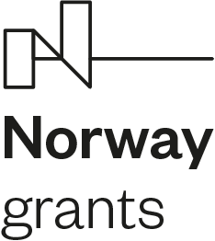

Name of project: The Awareness Raising on the jurisprudence of the European Court of Human Rights and other international human rights obligations of the Czech Republic
Reg. number: LP-PDP5-001
Term of relization: 1. 1. 2020 – 31. 12. 2023

Financing institution
Fond: Norway grants 2014-2021
Program: Human rights

Financing
Amount of the grant: 20 400 000 Kč
Norwegian funds share: 85 % (17 340 000 Kč)
State budget share: 15 % (3 060 000 Kč)

Project description
Goal of the project:
The PDP 5 aims to raise general awareness of human rights standards among state employees, legal professionals and public, which is currently at a rather low level as result of multitude information sources as well as linguistic barriers. Low awareness negatively affects human rights protection in the Czech Republic and effective implementation of human rights standards. An experienced and qualified state administration shall better fulfil and enhance human rights as well as prevent human rights violation. An educated public would play a better and more active role as a human rights watchdog and participate in human rights promotion and protection.

Key activities:
The project shall create and expand the information system about international human rights obligations of the Czech Republic. The project activities shall result in enhancement of available information sources and educational materials and their public presentation and diffusion. The goal is to create one comprehensive source in Czech language, carefully organized and updated on an ongoing basis, where all necessary information can be found in one place and are easily accessible.
Furthermore, to improve awareness and interest about human rights and their protection, the project partner (Charles University, Faculty of Law) will organise different educational activities for law students and public (e.g. courses, seminars, summer schools, internships and field trips) and issue different kinds of educational materials.
The project is composed of following 3 key activities:
1. Creation of an integrated web portal providing information on international human rights obligation of the Czech Republic
2. Creation of the electronic compatibility manual for legislators and organisation of related trainings
3. Educational activities with regards to human rights

